

-ACAIR080-

15 inch Slinky Claw Adapter

-ACAIR069-

15 inch Jumbo Slinky extension

Locking head

-ACAIR070-

10 ft. Jumbo Slinky extension

Locking head

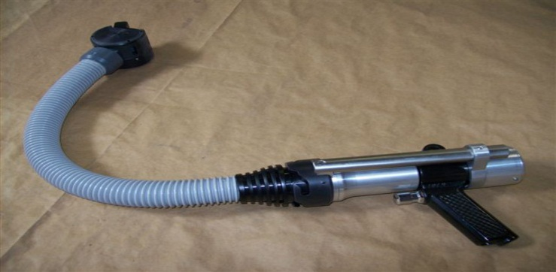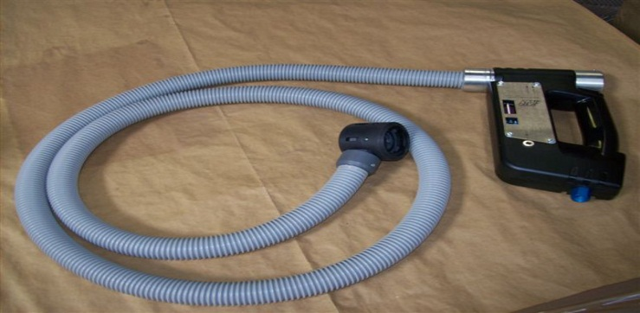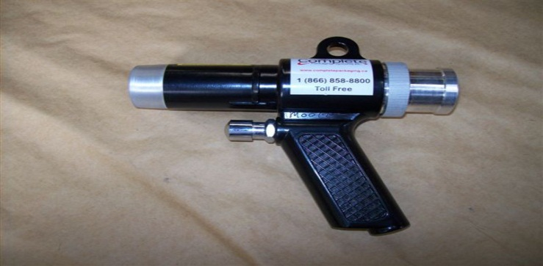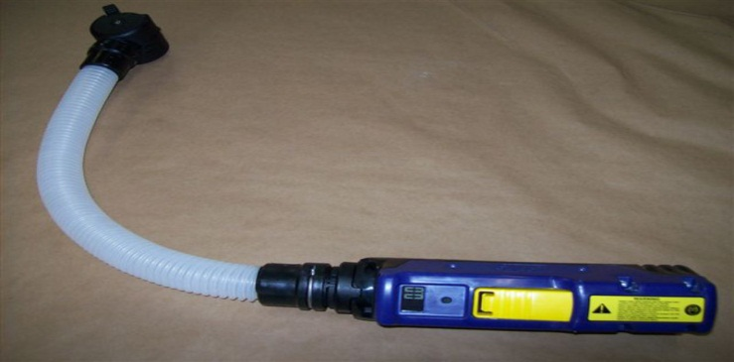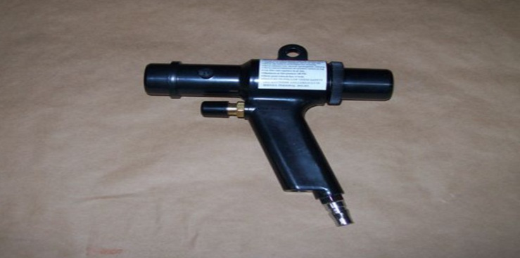

-ACAIR049-

OTR Only\*

-ACMAGVALVE-

Aluminum – OTR only\*

-ACAIR051-

w/ 15 inch extension (ACAIR069)

Bag Levels 1-5 compatible

-ACAIR062-

Digital interface w/ push to inflate button

-ACAIR021-

No longer a preferred tool

Better and cheaper options available